21.104: (a) The four possible diagrams are:

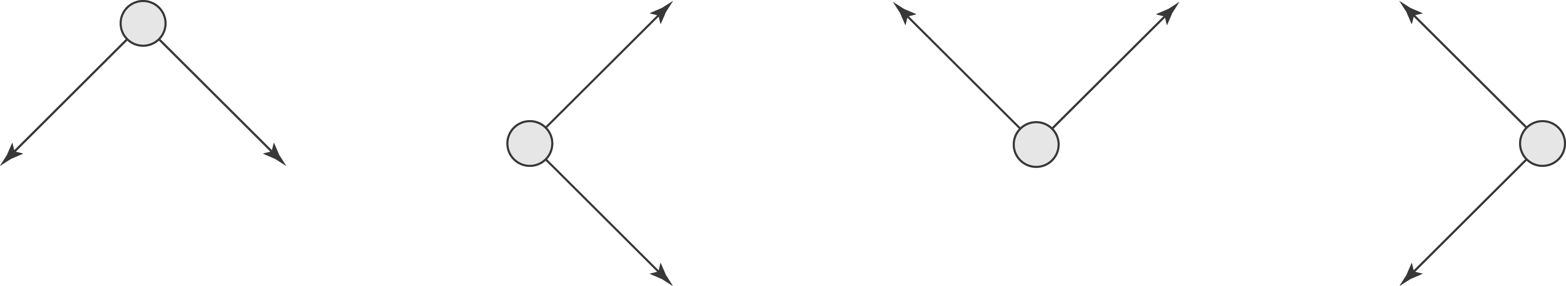

The first diagram is the only one in which the electric field must point in the negative y-direction.
b) 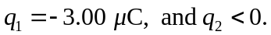
c)
